**Multi-Year Treatment Plan for**

**the Hulbert-Sage River Deer Wintering Complex**

Prepared by Kristie Sitar, Wildlife Habitat Biologist, Keith Magnusson, Newberry Forest Unit Manager, Dan Heckman, Forest Planning and Modelling Specialist, and Steve Carson, Wildlife Analyst

September 25, 2019

**Background for this Pilot Effort**

Deer Winter Range Guidelines were distributed to field staff in Wildlife and Forest Resources Divisions in 2013. This guidance provides biologists and foresters with a set of defining criteria by which to manage deer wintering complex’s (DWC’s) for sustainable use. There is a limitation to this approach in that it focuses mainly on stand level harvest prescriptions only in the current entry year. Recognizing this weakness, the authors of the DWC guidelines included the statement: “In DWC’s where there is mostly state ownership the vision is to develop an overall plan for the complex that will guide compartment review decisions.” Of the 46 U.P. deer wintering complexes identified in obligate winter range, 9 are comprised of substantial (>15,000 acres) state ownership (Figure 1.).

In March 2019, a memo was drafted by Kristie Sitar and Keith Magnusson to upper management of their respective divisions regarding the creation of a pilot treatment plan for the Hulbert-Sage River DWC, an obligate complex with abundant state ownership in the Eastern Upper Peninsula (EUP). Thevision of this pilot effort was to broaden the harvest planning horizon by preparing a landscape-scale treatment plan that stretched into future years. Such an effort would incorporate the existing Deer Wintering Range Guideline landscape goal of providing a roughly 50:50 mix of shelter and food resources for deer, while at the same time efficiently planning timber harvest treatments.

Subsequently Kristie and Keith were charged by DNR Director Eichinger and Deputy Director Hanna to proceed with development of a pilot plan. The Director also requested a pilot effort in the Western Upper Peninsula, and the Deerfoot Lodge DWC was selected due its abundant state land composition and obligate range classification. Dan McNamee, Monica Joseph and Ed Rice were selected to lead this effort. In addition, Dan Heckman and Steve Carson were chosen to develop necessary analytical tools and map products for the project.

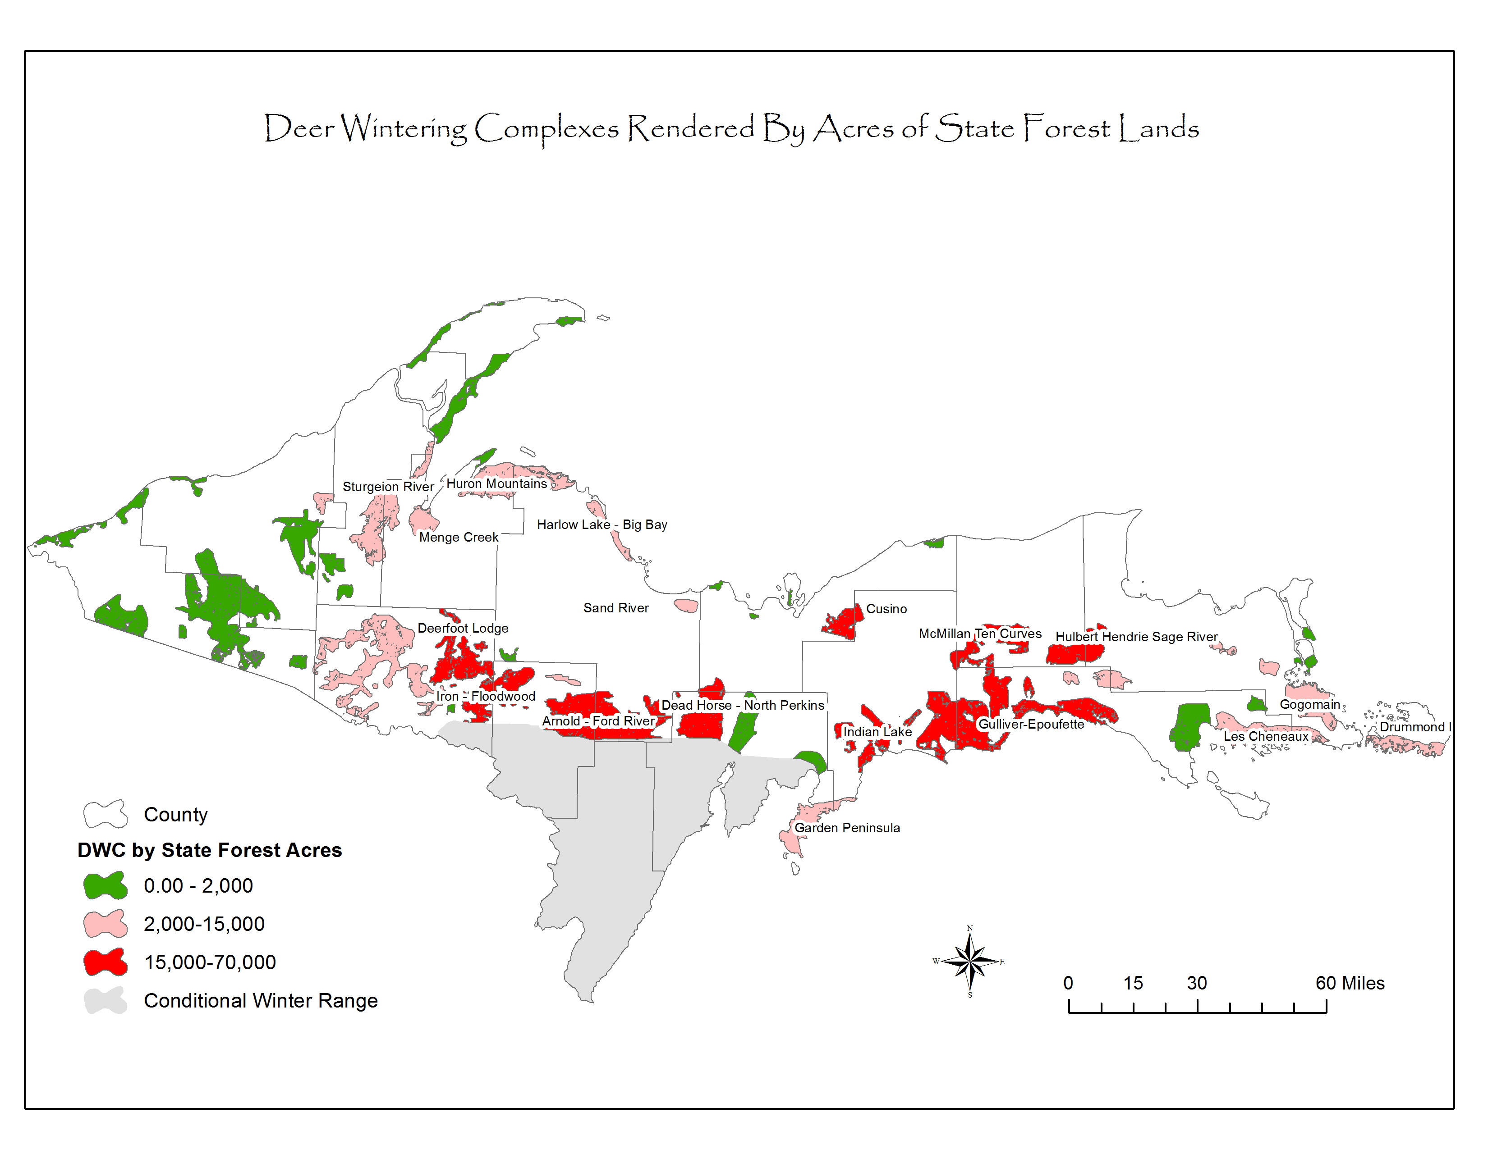

Figure 1.Deer wintering complexes in Michigan’s Upper Peninsula by state land acreage.

**Project Goal**

The plan vision is to design a balanced a timber harvest treatment plan using the existing forest cover types in the Hulbert-Sage River DWC to meet (or work toward achieving) the ideal habitat objectives of roughly a 50:50 ratio of shelter to food resources and distribute treatments over space and time to provide an even flow of food for deer. Additional benefits of this plan include balancing forest age classes and improving overall health and condition of the forest. Following are guiding principles:

* Management of the complex will protect primary shelter stands (cedar and hemlock) as well as enhancing food supplies through timber harvesting.
* Timber harvesting will generally occur in food producing stands (aspen, northern hardwoods, lowland mixed, lowland deciduous) and secondary shelter stands (mainly lowland conifer forests and some upland mixed conifer) that will be equally distributed over space and time in the complex.
* Overall this plan will be used to guide field staff in formulating treatment plans by considering the full range of habitat and timber management possibilities up front for the entire obligate deer wintering complex.

**Project Area**

The Hulbert-Sage River DWC is 80 square miles (~51,700 acres) and comprised of 63% state forest ownership (Figure 2.). Twenty-one state forest compartments are present, and 1-3 compartments are available for review in each entry year of a decade. The complex is currently comprised of 60% shelter and 40% food resources thereby indicating that a higher percentage of food resources would be ideal.

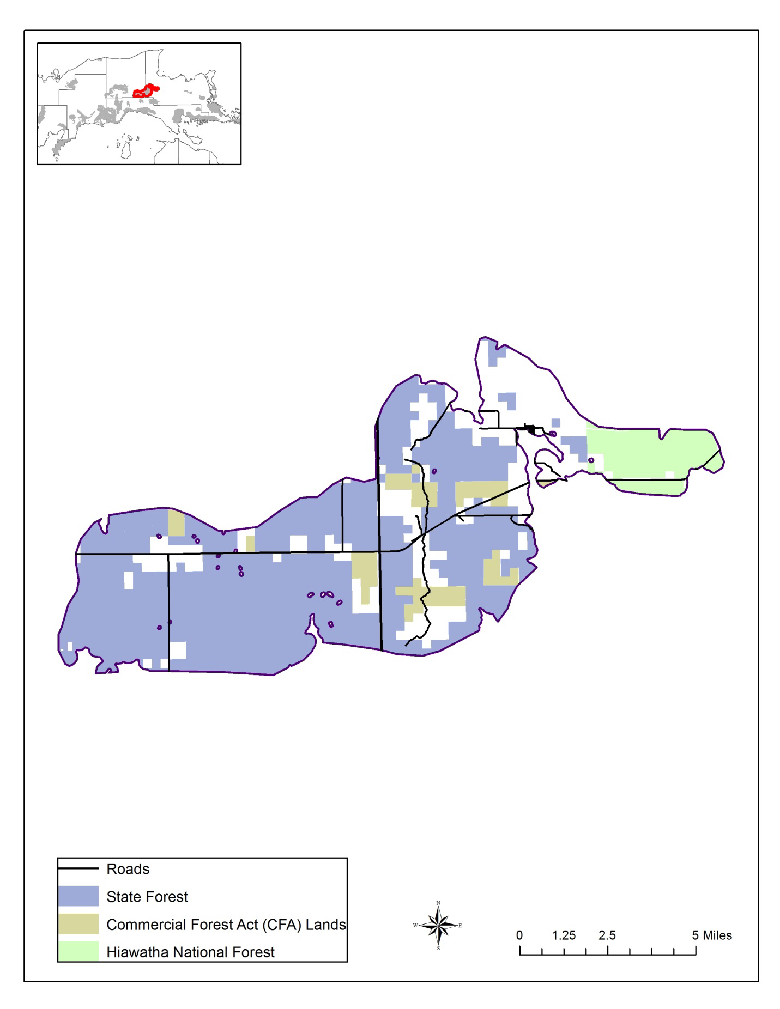

Figure 2. Hulbert – Sage River DWC ownership map.

**Project Constraints**

Consistency in developing long range treatment plans is important to achieving similar products with like capabilities. The following constraints were defined to guide development of standardized treatment plans and should be employed during future plan development for obligate DWC’s.

* Project is intended to be applicable to obligate DWC’s that are comprised of substantial state ownership (>15,000 acres).
* Primary shelter stands will be protected for deer shelter.
* Secondary shelter stands (mainly lowland conifer forest and some upland mixed conifer), which contain both shelter and food for deer, will be considered for harvest and regenerated in a rotational system that distributes treatments over space and time in the complex.
* Food-producing stands will likewise be scheduled for harvest and regeneration in a manner that spreads treatments over space and time in the complex.
* Project analysis is to include state land only.
* Compartment boundaries and Year of Entry (YOE) will remain unchanged. Analysis may show that YOE adjustments would be helpful in balancing harvests in the future, but no adjustments will be made prior to this analysis.
* Current DWC boundaries were used for analysis with the potential to include stands that extend outside of the boundary.
* Project considered a minimum 10-year planning horizon with the potential for a 20-year horizon if desired.
* Site Condition information in the forest inventory must be updated and current for the entire DWC. A recent effort by FRD achieved this.
* Stands with site conditions of “Too Wet” or “Blocked by Physical Obstacle” will not be managed and therefore are not considered in the analysis. However, stands with “Deer Wintering Area” site conditions do have the potential to be managed and are considered in the analysis.
* Categorize cover types as “Food”, “Shelter” or “Other” as appropriate with the awareness that some stands could provide both food and shelter in areas that are lacking substantially in either category (Appendix A).
* Stands in the “Other” cover type category (neither food nor shelter) are available for harvest using general silvicultural criteria and are not impacted by this analysis.
* Determine ideal rotation ages for significant cover types using Appendix N of the Michigan Forest Inventory (MiFI) manual provided here as Appendix B.
* Determine the ideal age class distribution for significant cover types. For example, aspen cover types could be managed on a 40-year rotation when the timber is merchantable in DWC’s where food is lacking.
* DWC analysis tools developed for this project will detail acres that have a treatment already prescribed. The DWC analysis tool will be used to determine sustainable harvests of important cover types in the DWC.
* When deciding which stands to harvest, use developed DWC analysis tools and map products to aid the decision-making process. In addition, lowland conifer stands with lower cedar and hemlock components and a higher food species composition could possibly be managed for conversion to food.
* Harvest planning will consider access logistics, marketability of timber, and timing of year for harvest. Manipulating the start date can be considered, but only in the decade of the inventory planning cycle.
* Individual stand prescription details will be annually drafted by field staff through the compartment review process using recommended harvesting strategies outlined in existing DWC guidance document.

**Building the DWC Analysis Tool and Map Products**

A DWC analysis tool was developed by Dan Heckman to determine sustainable harvest acres available for each cover type in the DWC. A resultant map product was created by Steve Carson to allow for visual distribution of harvests in the DWC. The following general constraints defined the model and map creation with substantially more detail provided in Appendix C.

* Datasets were developed from current MiFI data associated with the DWC boundary. Datasets include raw stand data, existing treatments, and site conditions.
* For stands bisected by DWC boundaries: any stand that was > 50% within the DWC boundary was considered entirely “in”. Any stand that was <50% within the DWC boundary was considered entirely “out” and therefore not included.
* Stands were categorized into Food, Shelter, and Other using existing cover type data.
* Stands that have hard factor site conditions for reasons other than Deer Winter Area are unavailable and were not considered.
* Shelter stands that have hard factor site conditions for Deer Winter Area are considered in analysis as there is possibility for conversion to food or regenerated to shelter.
* Display stand acres are already under contract or prescribed for treatment.
* Display cover type acres available for harvest over the next 10 years using silviculture criteria and site conditions.
* Map products were created in ArcGIS based on the stand data in the DWC analysis tool. Projections include available stands that met harvest criteria within the DWC boundary.

**Results of Analysis for the Hulbert-Sage River DWC**

The Hulbert-Sage River Deer Wintering Complex is comprised of 60% shelter and 40% food. The annual sustainable target harvest for food producing timber types was determined to be 121 acres. Furthermore, an annual target of 62 acres of secondary shelter types was identified for creation of additional food for the complex. Using the analysis tool, reviewing the map products, and considering stand composition of shelter stands, a detailed stand level treatment plan was developed (Appendix D).

The summary treatment plan acres in Table 1 below reflects stand acreage by YOE.  It should be noted that some years have either no food or no shelter harvests scheduled due to lack of availability during that year. For a small number of stands, the harvest year was modified (from the original YOE) to balance an even flow of available timber types representing food on the landscape. Other factors considered when selecting stands included accessibility and logistics of harvesting, marketability of the timber types, as well as age and health of the stands. The acres of selected stands resulted in an annual average of 128 acres of food and 49 acres of shelter.  This resulted in the treatment plan being very close to the target acres (72 acres under). Figures 3 and 4 depict the spatial array of proposed harvests.

Table 1. Proposed 10-year treatment acreage for the Hulbert-Sage River DWC. This represents the acres that will be harvested and regenerated.

|  |  |  |  |  |  |  |  |  |  |  |  |
| --- | --- | --- | --- | --- | --- | --- | --- | --- | --- | --- | --- |
| YOE | **2021** | **2022** | **2023** | **2024** | **2025** | **2026** | **2027** | **2028** | **2029** | **2030** | **Summary** |
| **Food acres** | 168 | 241 | 109 | 93 | 239 | 93 | 75 | 0 | 87 | 178 | Avg =128 |
| **Shelter acres** | 16 | 0 | 57 | 65 | 0 | 32 | 73 | 125 | 125 | 0 | Avg=49 |
| **Total acres scheduled** | 184 | 241 | 166 | 158 | 239 | 125 | 148 | 125 | 212 | 178 | Total =1776 |
| **Acres different from target** | +1 | +56 | -19 | -27 | +54 | -60 | -37 | -60 | +27 | -7 | Total = -72 |

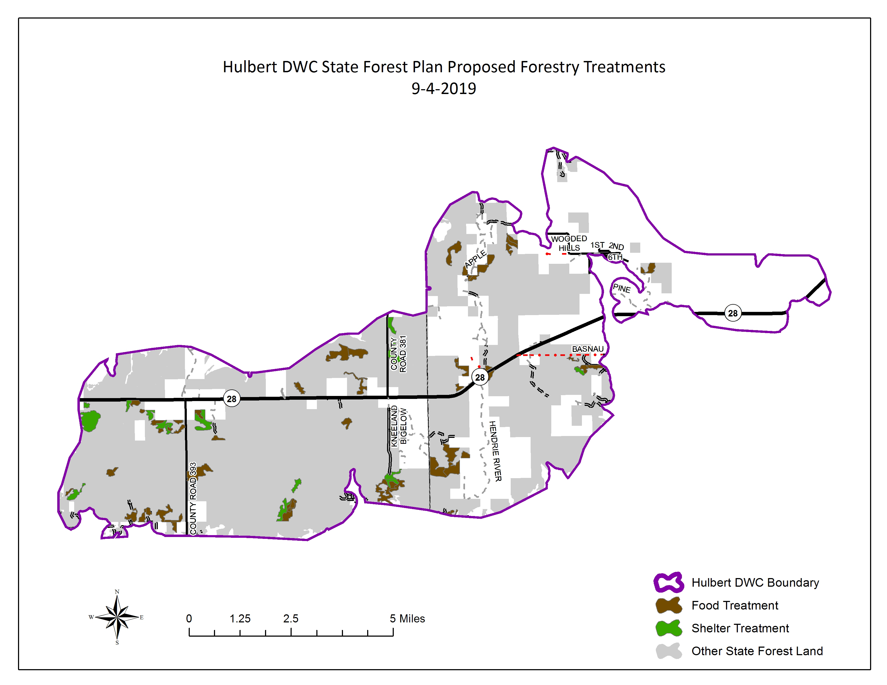

Figure 3. Proposed food and shelter treatments for Hulbert- Sage River DWC.

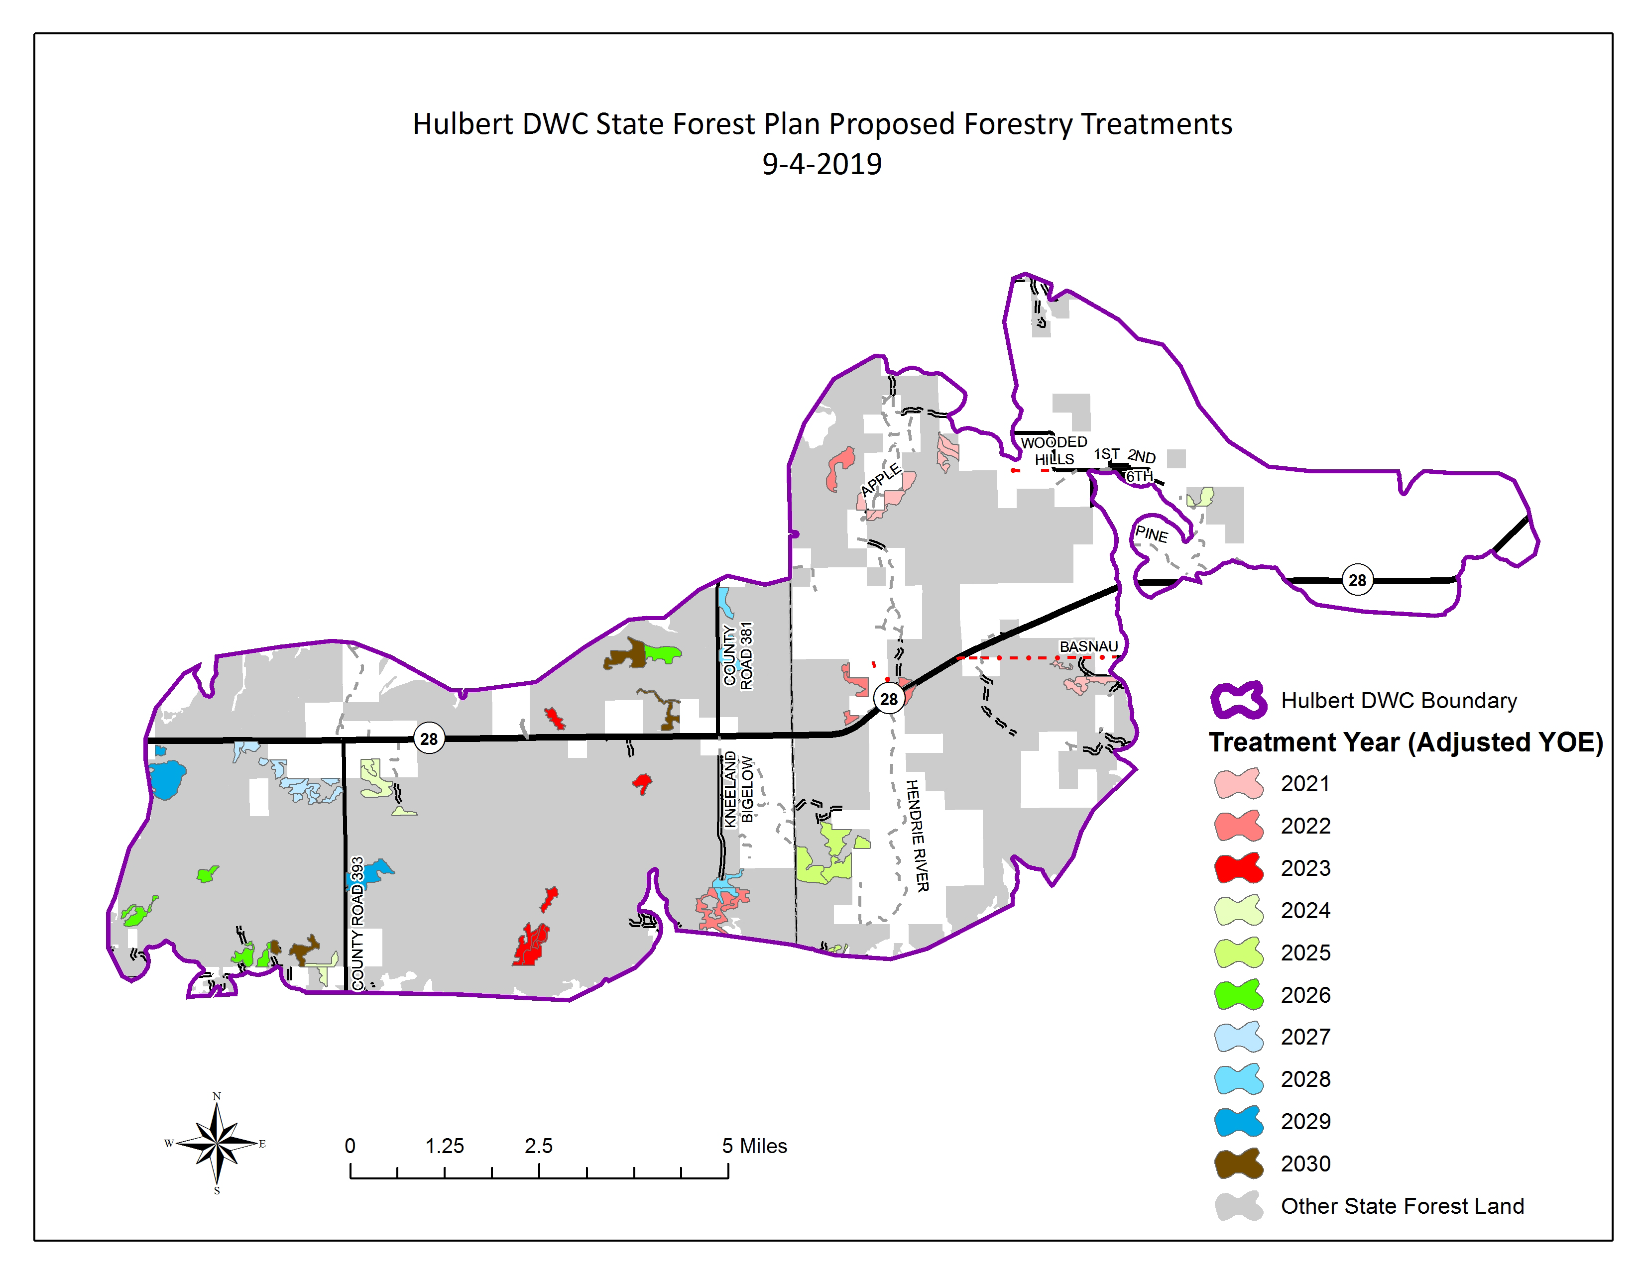

Figure 4. Proposed forest treatments by year of entry for Hulbert-Sage River DWC.

**Summary-Moving Forward**

It is recognized that each DWC has unique circumstances, however, the constraints defined here could be replicated for other obligate DWC’s to create a similar treatment plan. It is anticipated that annual adjustments to the treatment plan may be necessary due to changing dynamics that were not calculated in this project such as forest health issues and changing timber markets. However, the plan will provide practical operational guidance for field staff when making future assessments of treatment plans for a YOE and provide assurance that harvesting within the DWC is being conducted in a sustainable fashion for deer habitat and timber management.

While this project used a 10-year planning horizon, there may be a desire to model a treatment plan into future decades. However, there are limitations to the relatively simple analysis tool that was developed for this project. The Department of Natural Resources is actively involved in rewriting the Regional State Forest Management Plans (RSFMP) and using dynamic software (Woodstock by *Remsoft*) in that effort. It is possible that once operational, the Woodstock software would have the capability to produce a long-term habitat and timber harvest treatment plan that is more accurate and usable when looking into the future.

Lastly, this plan does not address the regeneration and recruitment of critical shelter species. It is likely that research of some type will be necessary to determine acceptable methods of regenerating and recruiting these types successfully.

**Plan Approval**

This plan and the enclosed treatment schedule will be approved using the compartment review process, similar to the approval process used for Grouse Enhanced Management Sites (GEMS) in recent years.

Appendix A. Forested Cover Type Assignment to Food, Cover and Other categories.

Shelter

* Cedar (primary shelter)
* Hemlock (primary shelter)
* Lowland Conifer (secondary shelter)
* Lowland Spruce/Fir (secondary shelter)
* White Pine (secondary shelter)
* Upland Conifers (secondary shelter)
* Upland Spruce (secondary shelter)
* Red Pine (secondary shelter)

Food

* Aspen
* Lowland Aspen
* Northern Hardwoods
* Lowland Deciduous
* Lowland Mixed Forest
* Birch
* Mixed Upland Deciduous
* Upland Mixed Forest
* Oak

Other

* Tamarack
* Jack Pine

Appendix B. Silvicultural Age for Forested Cover Types

Appendix N Generic Silvicultural Criteria (from MiFI manual)

***Stands exceeding the age and/or basal area (BA) ranges listed below for their appropriate cover type are***

***considered as having met 'Generic Silvicultural Criteria'.***

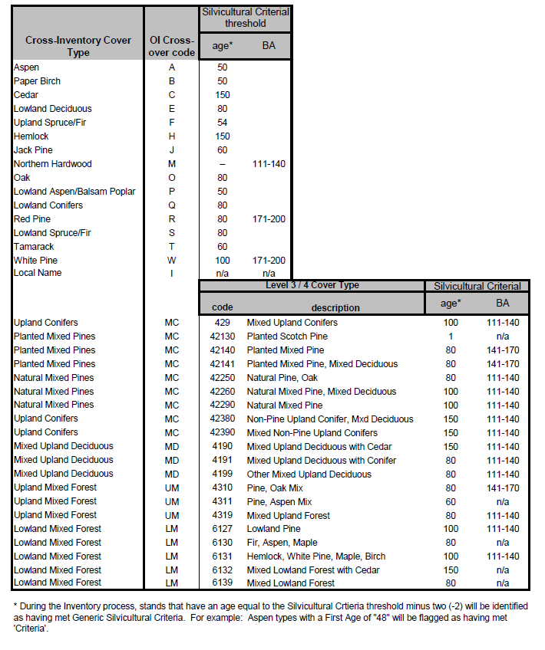

Appendix C. Deer Wintering Complex Analysis Tool

**Deer Wintering Complex Analysis Tool**

The management of forested stands on the state forest has been driven by the concept of area regulation for decades. Area regulation can be defined as having similar amounts of area (acres) in a defined number of age classes or basal area (BA) classes across a given landscape. Once a landscape is regulated, an even flow of resources is available, as habitat and forest products, over a given time period- often referred to as a planning period. In order to achieve a regulated forest, managers must define a few key attributes and perform an initial analysis to define the current condition. The following attributes are important to consider when determining the amount of harvesting and/or habitat needed in specific forest conditions:

* Extent of area to be managed
* Strata to be analyzed (forest covertypes)
* Rotation age or desired age/BA class distribution for each covertype
* Planning period
* Portion of area available for management
* Current age/BA class distribution
* Areas currently prescribed for management

Section 4 - Management Area Direction, of the Regional State Forest Management Plans (RSFMP), provide a target level of harvesting and subsequent regeneration for each of the major forest covertype in the 99 management areas (MA’s) across the state. All the above attributes were considered, and targets were provided to land managers and biologist through the compartment review process where plan implementation occurred.

An issue became apparent as foresters and biologist tried to implement the RSFMP’s in and around deer wintering complexes because of a few factors:

1. Deer wintering complex boundaries often cross management area boundaries or are a subset within a MA.
2. DWC’s have a pre-existing plan that contain management strategies that may differ from those of the broader MA.
3. The balance of food and shelter is important to DWC’s and the RSFMP does not provide an aggregated stratum of covertypes for each of those categories.
4. It is very difficult to assess covertype goals from the broader MA’s when only a small portion may affect the DWC and are often included in more than one inventory analysis document each year.

In order to resolve these factors surrounding the management of DWC’s, a custom analysis tool was built in Microsoft Excel which allows a more targeted and detailed look at a given DWC. The DWC analysis tool uses a similar approach to the RSFMP implementation tool but allows for quick adjustments to rotation age and merchantability for each forest covertype within the DWC. It also provides an allocated distribution of a 10-year goal to be implemented each year of the planning period.

In essence, the co-managers are able to specify a forest covertype, analyze the current age class distribution, enter attributes to illustrate a desired age class distribution, then have a calculated annual level of harvest provided to achieve those goals over the 10-year planning period.

The following workflow was used to create a solution to the management of the DWC’s:

1. The deer wintering complex boundary was used to essentially clip forest inventory data it overlaid.
   1. When stands, treatments, or site conditions were bisected by the DWC boundary it was determined that they should either be included in their entirety or excluded all together from the analysis.
   2. A systematic approach was taken where stands with greater than 50 % of their area inside of the boundary were included and those with less than 50% were excluded.
   3. The original DWC boundaries were not modified, only stands to analyze with respect to the DWC were “tagged”.
2. The clipped Forest Inventory data was then stratified by specific stand level attributes to allow for age and BA class distribution. Each stratum was then systematically tagged with a category of “Food”, “Shelter”, or “Other” for reporting purposes.
3. The stratified stand, treatment, and site condition data was then used for input into the DWC analysis tool where a combination of pivot tables and graphs, slicers, array formulas, custom dropdown menus and macros were used to provide outputs for guiding management decision.
4. Steps the user takes to conduct the analysis:
   1. The user first chooses a forest covertype (or multiple) to analyze by selecting it from the slicer.
   2. The various summary tables and age class distribution graphs automatically filter to show only that covertype data.
   3. Adjustments are made to the rotation age which define the number of age classes to balance in order to achieve a regulated state. The rotation age basically defines what the desired age class distribution will look like graphically and results in an even distribution line that informs the ten-year planning period harvest target.
   4. The merchantable age is then set which defines the minimum age class that can be used for harvesting to achieve the regeneration goals and helps to eliminate infeasible solutions.
   5. After these parameters are set, the user clicks an icon to reset the age class graph and calculate a planning period harvest target for the covertype that will meet the even distribution target.
   6. The planning period target is allocated across each year of entry using a relative proportion approach where:
      1. The harvest target for a given YOE is equal to a percentage of the overall planning period target.
      2. A YOE target is calculated by the relative proportion of merchantable-available acres of a covertype in that particular year of entry out of the total merchantable-available acres of that covertype in all years of entry.
   7. The following logic is used in calculations for the DWC analysis tool:
      * 1. There are 2925 acres of aspen in the Hulbert / Sage River DWC.
        2. Of that, 2741 acres are available for commercial forest management.
        3. The desired age class would include equal amounts of acreage in 6 age classes, with a 50-year-old rotation age once regulated.
        4. 2741(ac) / 6 (age classes) = 457 (ac in each age class)
        5. The ten-year planning period target would be to harvest about 457 acres to create 457 acres of regeneration in the 0-9 age class. If this is repeated over several planning periods, managers will build the desired age class distribution.
        6. Those harvests can only come from stands that are available and merchantable, making it necessary to evaluate if the current age class distribution provides enough of those acres to feasibly reach 450 acres.
        7. In order to provide management direction for each compartment review cycle, it is necessary to allocate the ten-year planning goal of 450 acres across each year of entry in the planning period.
        8. This is done using the relative proportion approach described above. If there is 15% of the merchantable-available aspen of the entire DWC in the 2021 year of entry, then the harvest target is 15% of the ten-year goal (2021 YOE harvest goal= .15 X 457 = 69 acres). Years with higher proportions of merchantable-available acres have higher targets, lower proportion years have lower targets. If the process is allocated this way across all years, the planning period target (even distribution line) is reached at the end of the planning period.
        9. The areas already under prescription from past years are also considered and deducted from the planning period forecast if they are projected to be completed during this planning period.
        10. Because it takes on average about 4 years from prescription decisions to regeneration on the ground, we must adjust the planning period to account for all prescriptions in the last four years as incoming regeneration and provide prescriptions for the next six years. The last four years of the planning period can be prescribed and forecasted, but the regeneration will not be in place during this planning cycle, so it will be counted in the next planning period.
5. The amount of food vs. shelter is also easily calculated and displayed for managers to evaluate the current condition and consider treatments that may shift stands one way or another over time.
6. Basal Area distribution is also evaluated for stands managed based on density rather than age alone (e.g. Northern hardwood, red pine, white pine). The ideal BA distribution varies by covertype and the analysis tool provides a look at the current distribution, and an idea of what will be ready for thinning or selection harvests in each year of the planning period.
7. As managers work through each forest covertype, the management decisions are recorded at the stand level in the harvest schedule table.
8. This harvest scheduled and associated maps will be brought into the compartment review meetings to help guide management of stands that fall within the DWC’s where the RSFMP management area targets may not align with DWC management.

Moving forward, the management of DWC’s will be more incorporated into the regional state forest management plans. The use of *Remsoft Woodstock* forest modeling software as a planning tool will allow for a more comprehensive approach where management goals may differ because of one factor or another. Longer term planning horizons can also be modeled, and treatment schedules can be created that provide control over stand conditions in the DWC, or perhaps optimize for certain conditions within the DWC’s. This analysis tool provides a good starting point when applying the concept of area regulation to the DWC’s, but there are many factors beyond age and BA class distribution that should be considered moving forward that require more sophisticated tools to evaluate appropriately. This will likely prove to be complicated work but will provide the best solutions in sustainably managing both the habitat and forest resource needs within the various deer wintering complexes.

Appendix D. Treatment plan for Hulbert-Sage River DWC



|  |  |  |  |  |  |  |  |  |  |  |  |  |  |  |  |  |  |  |  |  |  |  |
| --- | --- | --- | --- | --- | --- | --- | --- | --- | --- | --- | --- | --- | --- | --- | --- | --- | --- | --- | --- | --- | --- | --- |
| **Harvest Schedule (Stand #'s)** | **YOE** | **2021** | | **2022** | | **2023** | | | **2024** | | | **2025** | | | **2026** | | **2027** | **2028** | **2029** | **2030** | | |
| **Compartment** | **71** | **74** | **73** | **134** | **75** | **131** | **133** | **70** | **127** | **128** | **76** | **135** | **136** | **72** | **126** | **121** | **130** | **120** | **125** | **129** | 132 |
| **Food** | Aspen | 37,39 |  | 48,54,55 |  |  |  | 14 |  |  | 65,48 | 29,8,31 |  |  |  | 51,55 | 77 |  |  |  |  | 62,58 |
| Northern Hardwood | 27,32,38 | 29 |  | 40,44 |  | 103 |  |  |  |  | 5,30 |  | 25* |  |  |  |  |  |  | 42,37 |  |
| Lowland Deciduous | 24,35* |  |  |  |  | 33 |  |  |  |  | 7 |  |  |  |  | 70,88 |  |  |  |  | 51E*,51W |
| Lowland Mixed Forest |  |  |  |  |  |  |  |  | 80 |  |  |  | 26* |  |  | 60,64 |  |  |  |  |  |
| Lowland Aspen/Balsam Poplar | 23 |  | 57,86 |  |  |  |  |  |  |  | 4 |  |  |  | 19,20 |  |  |  |  | 43*,17* |  |
| Mixed Upland Deciduous |  | 15,22 |  |  |  |  |  |  |  |  |  |  |  |  |  |  |  |  |  |  |  |
| Upland Mixed Forest |  |  |  |  |  | 111 |  |  |  |  |  |  |  |  |  | 82 |  |  |  |  |  |
| Paper Birch |  |  |  |  |  |  |  |  |  |  |  |  |  |  |  |  |  |  |  |  |  |
| **Shelter** | Cedar |  |  |  |  |  |  |  |  |  |  |  |  |  |  |  |  |  |  |  |  |  |
| Lowland Conifers |  |  |  | 41* |  | 83,106 | 59* |  |  | 54 |  |  |  |  | 22 | 41, 86 |  | 32 |  |  | 10*,16* |
| Upland Conifers |  |  |  |  |  |  |  |  |  |  |  |  |  |  |  |  |  |  |  |  |  |
| Upland Spruce/Fir |  |  |  |  |  |  |  |  |  |  |  |  |  |  |  |  |  |  |  |  |  |
| Red Pine |  |  |  |  |  |  |  |  |  |  |  |  |  |  |  |  |  |  |  |  |  |
| Hemlock |  |  |  |  |  |  |  |  |  |  |  |  |  |  |  |  |  |  |  |  |  |
| Lowland Spruce/Fir |  | 48 |  |  |  |  |  |  |  |  |  |  |  |  |  | 75,68 |  | 24 |  |  |  |
| White Pine |  |  |  |  |  |  |  |  |  |  |  |  |  |  |  |  |  |  |  |  |  |
|  |  |  |  |  |  |  |  |  |  |  |  |  |  |  |  |  |  |  |  |  |  |

|  |  |  |  |  |  |  |
| --- | --- | --- | --- | --- | --- | --- |
| **Change of start date stands** | |  |  |  |  |  |
| **YOE** | **Cover type** | **Cmpt** | **Stand** | **Acres** | **Start date** | **Adjusted YOE** |
| 2021 | lowland deciduous | 71 | 35 | 55 | 10/01/2021 | 2022 |
| 2015 | lowland mixed | 136 | 26 | 24 | 10/01/2023 | 2024 |
| 2015 | northern hardwood | 136 | 25 | 7 | 10/01/2023 | 2024 |
| 2030 | lowland aspen | 129 | 17 | 87 | 10/01/2028 | 2029 |
| 2022 | lowland conifers | 134 | 41 | 18 | 10/01/2027 | 2028 |
| 2023 | lowland conifers | 133 | 59 | 25 | 10/01/2027 | 2028 |
| 2027 | lowland conifers | 121 | 86 | 10 | 10/01/2024 | 2027 |
| 2030 | lowland conifer | 132 | 10 | 27 | 10/01/2027 | 2028 |
| 2030 | lowland conifer | 132 | 16 | 55 | 10/01/2027 | 2028 |
| 2030 | lowland aspen | 129 | 43 | 18 | 10/01/2023 | 2024 |
| 2030 | lowland deciduous | 132 | 51E | 63 | 10/01/2025 | 2026 |